**INTRODUCTION**

This dataset is a collection of public information from Brazilian e-commerce orders, encompassing details from 115,000 transactions across various global marketplaces. The dataset's attributes provide a comprehensive perspective on each order, covering aspects such as order status, pricing, payment and shipping performance, as well as customer location, product characteristics, and shipment details.

Following a customer's purchase on the online store, the seller receives a notification to fulfill the order. Subsequently, upon the customer's receipt of the product or upon the estimated delivery date, the customer receives an email containing a satisfaction survey. In this survey, the customer can assign a rating to their purchasing experience and include comments.

**PROBLEM STATEMENT**

A. Business overview of the Current Year and Previous Year

1. Find YTD, QTD, PQTD Sales, Profit and Quantity
2. What are Current Year Sales and Profit trend for different Market around the globe?
3. Comparison of Current Year and Previous year Sales for different Category

B. Market Analysis

1. Percentage of sales with respect to different Market Region

2. Sales/Profit by Country for different Regions

3. Use Pareto Analysis to find the best performing countries

C. Product Analysis

1. What are the bestselling product categories? For each Product Category compare Sales, Order Quantity, Profit per order, and Profit margin

2. Do a Market Basket Analysis to know the pattern of product purchase

D. Customer Segment Analysis

1. Customer Segment Analysis to find Sales, Order Quantity, Customer Count, Profit, Profit margin for each Segment

2. Ranking of Market Region for number of Customer count each Year

3. Find Customer Order Frequency

E. Shipment Analysis

1. Find Total Shipments completed, Ongoing Shipments, Average days to ship a product, number of on time deliveries and % of on time deliveries

2. What is country wise average shipping days?

3. What is Ongoing deliveries status?

**DATA DESCRIPTION**

This comprises commercial data that has undergone anonymization, with any mentions of companies and partners in the review text substituted with alternative names. The data underwent cleaning in accordance with specified criteria, filling in blank fields to provide meaningful information within the domain's context. Date fields were also cleaned, and any instances of null dates were populated with appropriate dates.

**Metadata:**

1. Total number of rows – ~115K
2. Total number of Fields – 43
3. Visualization Tool – Tableau Desktop
4. DS Connection – Extract

**METHODOLOGY**

Initially, the problem was delineated, and questions for data analysis were formulated. Stakeholders for the project were then pinpointed. Subsequently, sources were located, data was gathered, and superfluous information was removed. The data analysis was executed, leading to the creation of the initial dashboard. Upon confirming that the prototype aligns with the project's objectives, the task at hand involves procuring the actual data and constructing the final dashboard. Lastly, the dashboard needs to be shared and maintained to transform it into a practical tool for the intended audience.

**DESIGN METHODOLOGY**

**Main Story Line**

This represents a Story Point encompassing all the dashboards in a narrative format. Clicking on a specific story point will provide information from the corresponding dashboard.

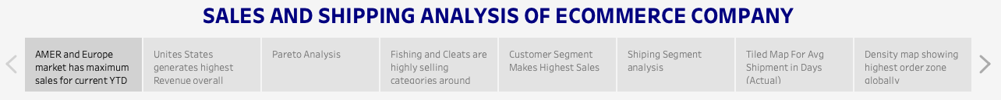

**Dashboard 1**

The First Dashboard shows the Current Year and Previous Year Overview of the Business. It consists of YTD, QTD and PQTD KPI for Sales, Profit and Quantity Sold. Combo chart with column and line chart and a candle chart.

**Dashboard 2**

The Second Dashboard shows the Market Analysis. The dashboard has Filled Map chart with different regions, custom rounded bar chart, and a Pareto principle based chart.

**Dashboard 3**

The Third Dashboard shows Product Analysis. The dashboard contains a combo of bar chart and a lollipop chart to show different measures to analyse product, Basket Analysis chart to show the purchase pattern.

**Dashboard 4**

The Fourth Dashboard shows Customer Segment Analysis. It contains a KPI Bar chart to show different measures, Pie chart, Bump or Rank chart, and a Frequency chart

**Dashboard 4**

The Fifth Dashboard shows the Shipment Analysis of the products. It contains a KPI banner to show different parameter for shipping, filled map country chart, and a grid view to show the ongoing status of deliveries.

**TABLEAU DASHBOARD**

**Dashboard 1**

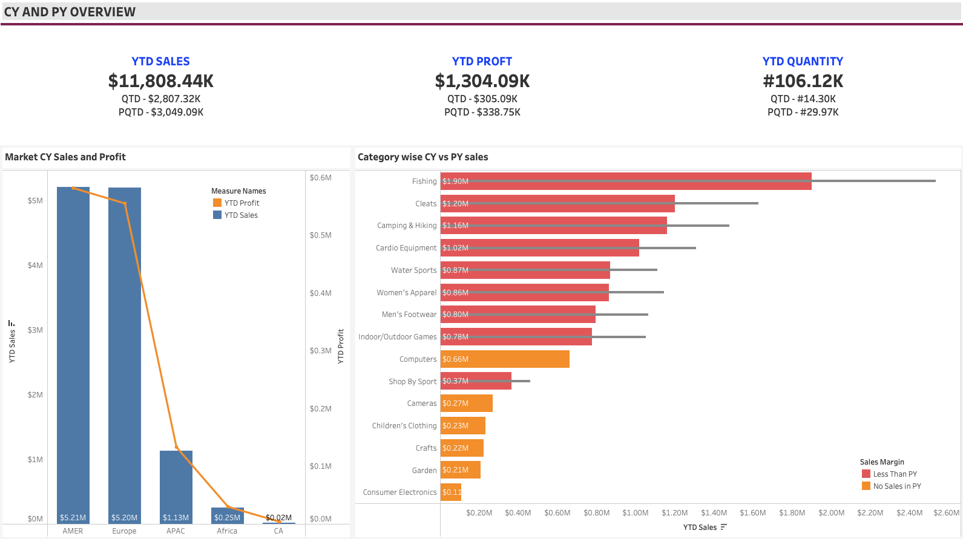

**Dashboard 2**

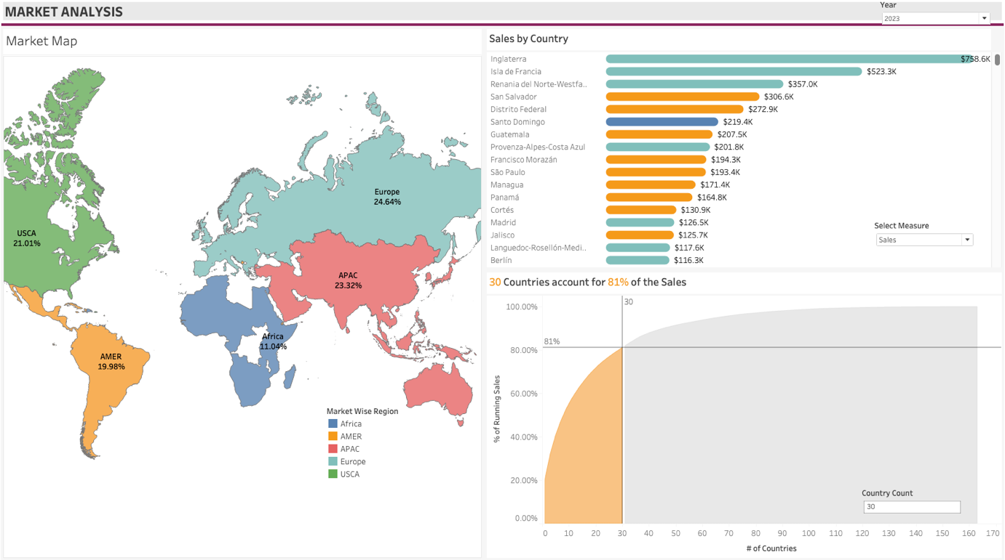

**Dashboard 3**

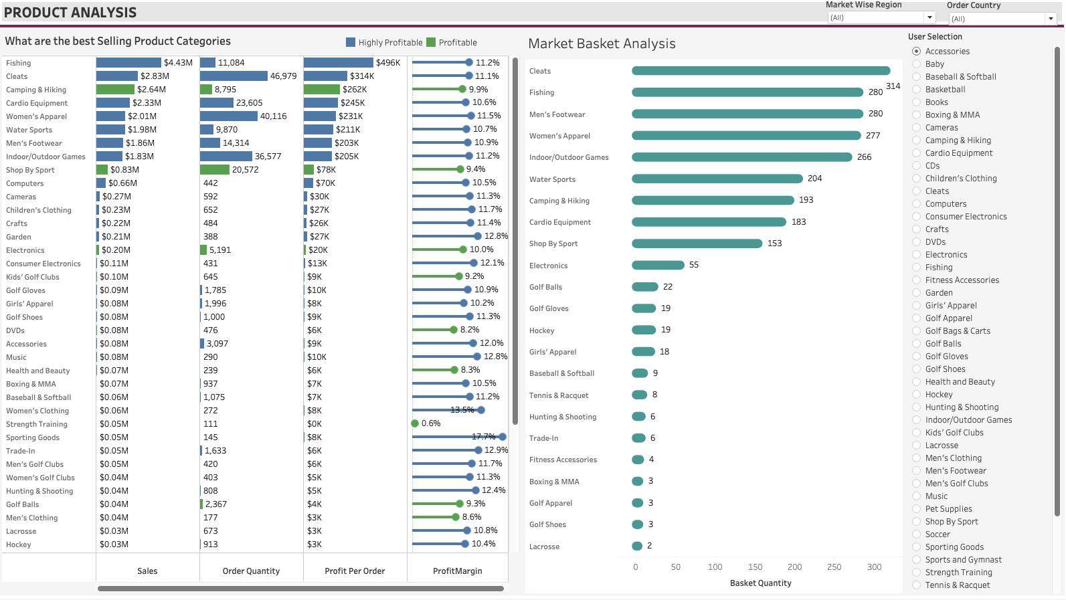

**Dashboard 4**

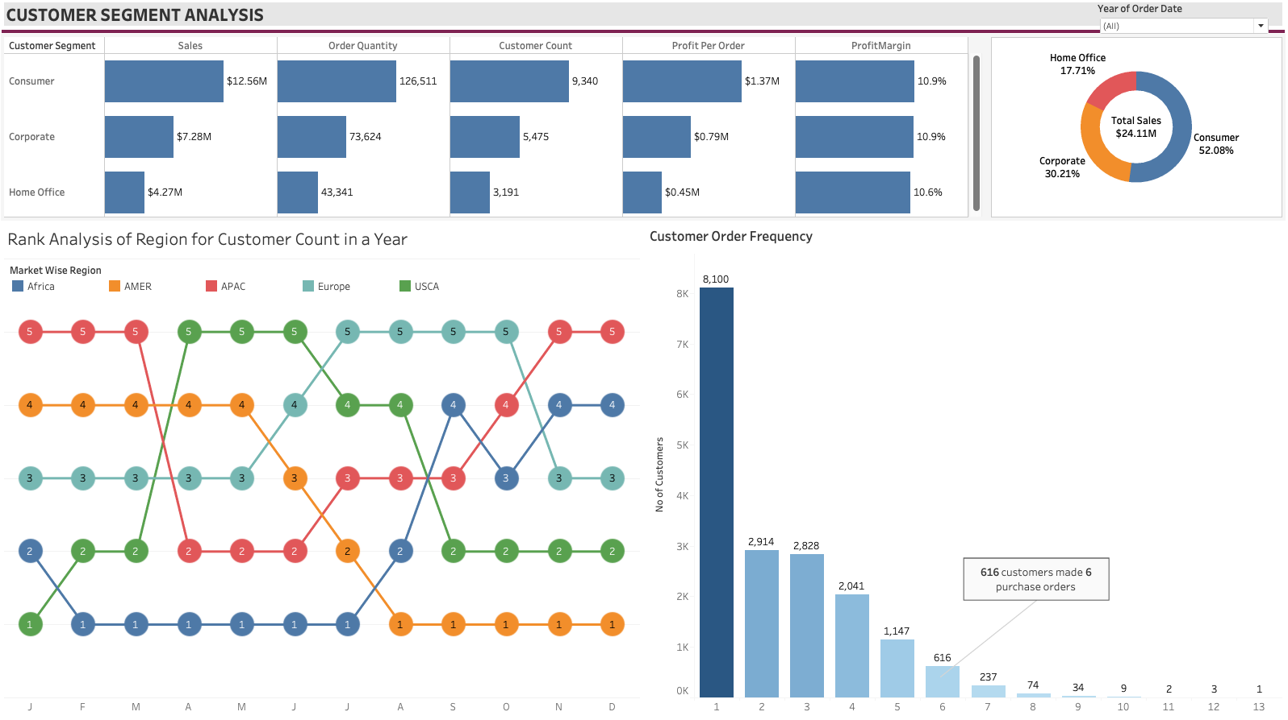

**Dashboard 5**

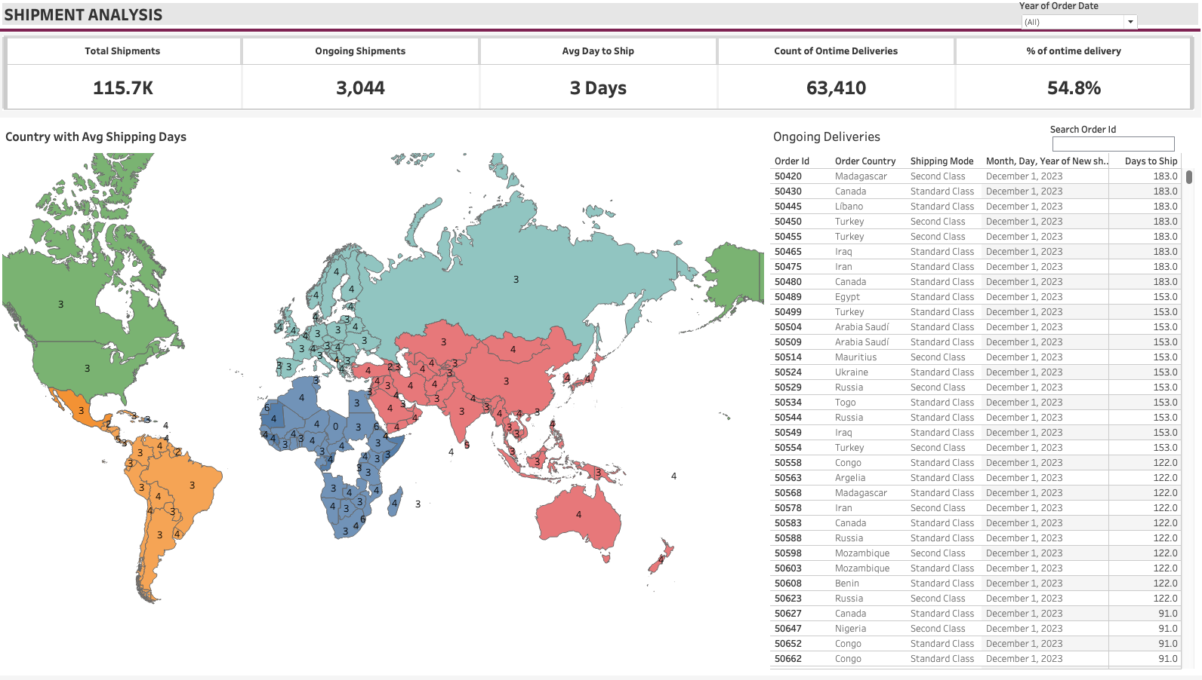

**GAINED INSIGHTS**

1. Quarterly-to-date (QTD) Sales exhibit a decline compared to the Previous Quarter-to-date (PQTD) Sales, indicating a consistent Quarter-on-Quarter downturn in business. This trend is mirrored in Profit and Quantity Sold, with both metrics decreasing Quarter-on-Quarter.
2. The AMER and EMEA Regions collectively contribute nearly 80% of the total Market Share, surpassing other regions.
3. The Fishing Category stands out as the top-selling category market-wide. Computer, Children Clothing, Crafts, Cameras, and Garden are newly introduced categories for the year 2017, with the Computer category being the highest performing among them.
4. The company commenced product sales in the AMER Region in 2023, quickly capturing 44.08% of the market share.
5. Only 30 countries worldwide contribute approximately 81% of the total sales.
6. Product Analysis enables users to evaluate individual product performance, with filters available for Region and specific Country selection. It provides insights into product performance based on Sales, Order Quantity, Profit per order, and Profit Margin.
7. Basket Analysis assists users in understanding customer purchasing patterns, aiding retailers in effective inventory management to meet supply and demand.
8. Consumer Segment constitutes 52.08% of the total market share, while the Home office segment contributes the least share at 17.17%.
9. Customer order frequency to purchase more than one item peaked in the year 2022, with 2621 customers making a maximum purchase of 3 items. This figure dropped to 2325 in 2023.
10. The average shipping time worldwide is 3 days, reflecting excellent shipping management.

**CONCLUSION**

The company successfully entered the new AMER region, contributing 44.08% to the total Market Share. However, QTD sales decreased compared to PQTD sales due to underperformance in other market regions. This underscores the need for attention to marketing strategies in these regions and the introduction of new products to stimulate sales.

**SOURCES**

1. Ecommerce insights AI- <https://ecommerceinsights.ai/#:~:text=eCommerceInsights.ai%20offers%20an%20AI,faster%20and%20ultimately%20sell%20more>.